# QUIZ - Spot the difference

**Question 1**

Parte superior do formulário

**Below is a plot from a large NHANES sample used to investigate age of first marijuana use.**

Confidence intervals (red) and comparison intervals (blue) have been drawn on the graph to help investigate the questions, “For people who have used marijuana, at what age did they first try the drug and are there differences between ethnic groups?”

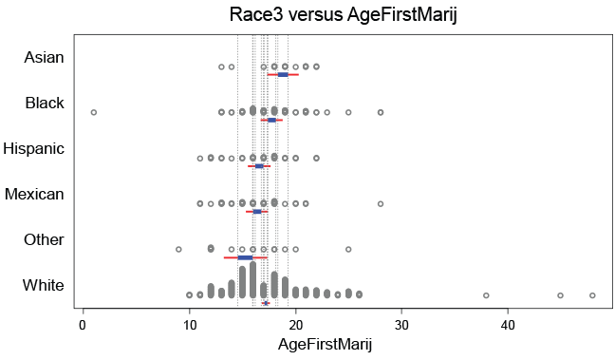  
Select the statement that is **FALSE**.

There is no difference between the population means for age-of-first-use between the Hispanic and Mexican ethnic groups .

The difference in the population mean age-of-first-use between the Asian and Black groups could be quite small or it could be several years.

We can be fairly confident that the population mean age-of-first-use for the White ethnic group is younger than for the Asian ethnic group.

The 95% confidence interval for the population mean age-of-first-use for the Other group extends from an age of about 13 to about 18.

The narrow intervals for the White group are not an indication of low variability in age-of-first-use values in the White group.

**Correct**

This statement is **FALSE** – If the comparison intervals overlap substantially, the true difference could go in either direction, or there might not be one at all. We simply don’t know.

Parte inferior do formulário

## Question 2

**Here is a plot of 1000 participants from the NHANES survey showing the proportion of people who have used hard drugs, broken out by whether participants have regularly used marijuana.**

*Comparison intervals* have been drawn on the plot.

[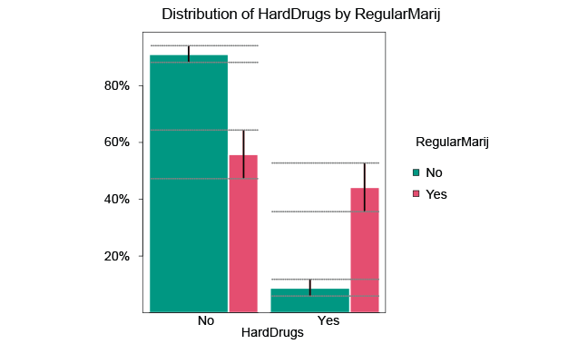](https://flexiblelearning.auckland.ac.nz/data-to-insight/8/2/images/quiz3b.png)

Select the statement regarding this plot that is **FALSE**.

The pink bars belong to those who said yes to the regular marijuana-use question. The green bars belong to those who said no to the regular marijuana-use question. The outcome variable is whether they said yes or no to having used hard drugs.

There is more uncertainty about the true population percentage of yes-answers to the hard drug question for people who say they have been regular marijuana users than for those who say they have not been regular marijuana users.

**We cannot tell whether those who claim to have used marijuana regularly are more likely to say they have used hard drugs than are those who claim they have not used marijuana regularly.**

Comparison intervals allow for the uncertainties in comparisons between true values due to sampling error.

**Correct**

This statement is **FALSE** – The comparison intervals on the pink and green bars on the right-hand side (hard-drugs=yes) are clearly separated. It is clear that those who have used marijuana regularly are much more likely to say they have used hard drugs than are those who have not used marijuana regularly.